**1 ARMA model**

The Auto regressive Moving Average (ARMA) model for time series yt is a deterministic model with an input time

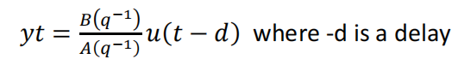

The Arma model is contructed from the a and b coefficients and the respective data values

The formula

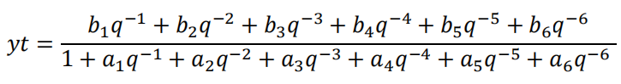

We write down the model, the cost function of least square estimation and its gradient as following:

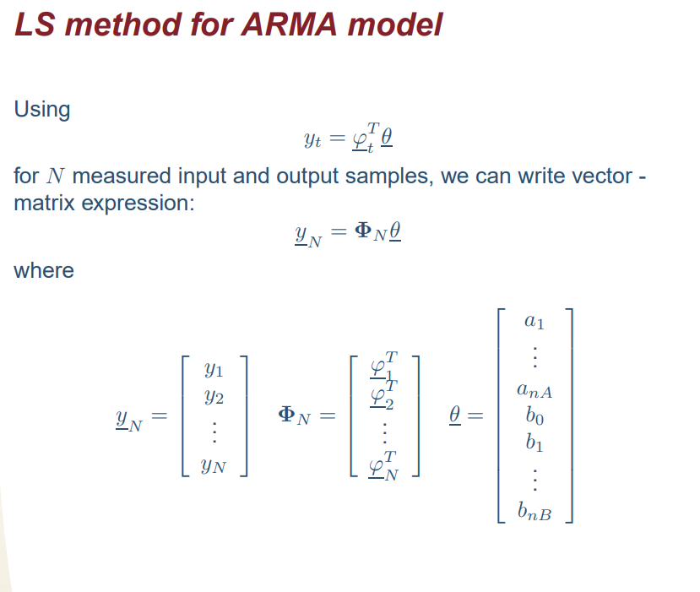

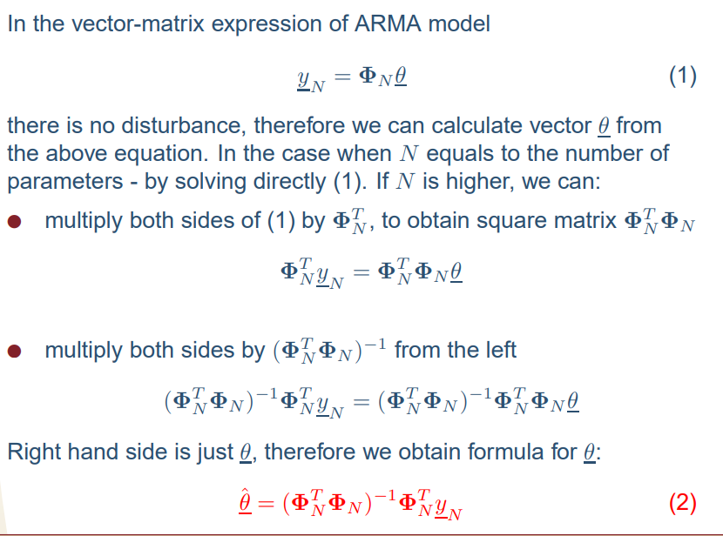

Let us consider the case for an ARMA(6,6) model without delay, such that d = 0 and b0 = 0. The

time series is given in the data file 15_ARMA.mat. The parameters vector, θ had these values :

Theta =

-0.5000

0.6000

0.3000

0.2000

-0.2000

0.3000

-8.8000

5.2000

-4.9000

1.6000

-0.7000

0.2000

For the parameters, finally obtain a discrete transfer function of model with sampling time of 0.1

G_d =

-8.8 z^5 + 5.2 z^4 - 4.9 z^3 + 1.6 z^2 - 0.7 z + 0.2

---------------------------------------------------------

z^6 - 0.5 z^5 + 0.6 z^4 + 0.3 z^3 + 0.2 z^2 - 0.2 z + 0.3

**2 ARX model**

The transfer function form of the ARX model specification is

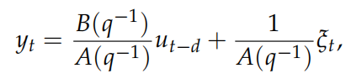

In the ARX model, we include the disturbance, the Least square method in this model is based on the minimizing of the squared errors, Vn between the measured output of the system and the measured output of the model. We take into account that we can’t measure the disturbance hence we use the one step ahead method. The calculations of the parameters, θ is similar to the ARMA model above.



The Akaike information criterion suggests that the best result of the least square estimation of the

ARX process is obtained when one chooses the optimal order *n*, according to

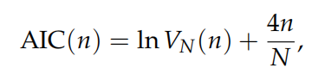

Where VN(n) is the error of the least square estimation at optimal parameter with model order n.When we calculate the AIC values for each of the assumed order, in our case m=10 we can compare the values for each of these AIC values.

Vn 1 - 10

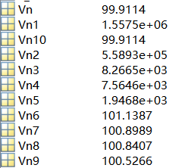

AIC m= 1 - 10

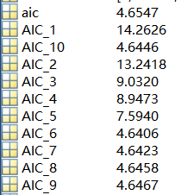

The AIC which is lowest is for the order 6. Meaning our order for the ARX has order 6. It is represented by this transfer function with its parameters with a sampling time of 0.2.

model =

0.8034 z^5 + 0.5016 z^4 + 0.9005 z^3 + 0.5022 z^2 + 0.3009 z + 0.1005

-------------------------------------------------------------------------

z^6 + 7.799 z^5 - 6.173 z^4 + 0.8726 z^3 - 0.2926 z^2 - 0.1959 z + 0.0049